STAT 8120 – Module 8 Homework

Due 4/12/2020

Connor Armstrong

***8.4*** *Problem 6.30 describes a process improvement study in the manufacturing process of an integrated circuit. Suppose that only eight runs could be made in this process. Set up an appropriate 25−2 design and find the alias structure. Use the appropriate observations from Problem 6.28 as the observations in this design and estimate the factor effects. What conclusions can you draw?*

**8.4 Conditions**

|  |
| --- |
| *8.411 Data is obtained from problem 6.30. Compare results with full model analysis of 6.30 data.* |

***Table 8.4.1 Unreplicated 25 Design from Problem 6.30***

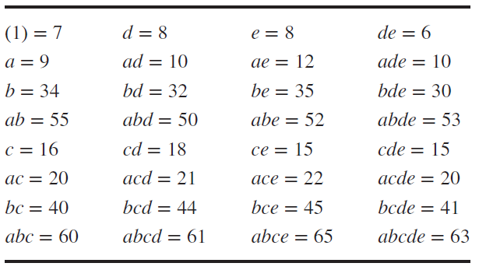

The first step for manually generating a one-quarter fractional factorial design is to write the main effects design matrix for k-2 factors. This design is a full main effect basic design for 5-2=3 factors A, B, and C having 8 runs.

Table 8.4.2 Creating a 25-2III Design from a 23 Design Matrix

|  |  |  |  |  |
| --- | --- | --- | --- | --- |
| **Basic Design** | | | **New Factors** | |
| **A** | **B** | **C** | **AB=D** | **AC=E** |
| - | - | - | + | + |
| + | - | - | - | - |
| - | + | - | - | + |
| + | + | - | + | - |
| - | - | + | + | - |
| + | - | + | - | + |
| - | + | + | - | - |
| + | + | + | + | + |

The second step is to evaluate the generating relations and the defining relation for the fractional design. The generating relations ie design generators for the selected design are I = ABD and I = ACE and the defining relation becomes I = ABD = ACE = ABD*ACE = BCDE.

The third step is to evaluate the “new factors” as shown in table 8.4.2.

The fourth step is to declare the complete defining relation: I = ABD = ACE = ABD*ACE = BCDE.

The fifth step is to evaluate the aliasing structure:

A = A*I = A*ABD = BD; A = A*ACE = CE; A = A*BCDE = ABCDE

A = BD = CE = ABCDE

B = AD = ABCE = CDE

C = ABCD = AE = BDE

D = AB = ACDE = BCE

E = ABDE = AC = BCD

BC = ACD = ABE = DE

BE = ADE = ABC = CD

The appropriate observations are selected and displayed in the table below along with the design matrix:

Table 8.4.3 One-Quarter Design with Selected Observations

|  |  |  |  |  |  |  |
| --- | --- | --- | --- | --- | --- | --- |
| **Basic Design** | | | **New Factors** | | **Selected Observations** | |
| **A** | **B** | **C** | **AB=D** | **AC=E** | **Combination** | **Response** |
| - | - | - | + | + | DE | 6 |
| + | - | - | - | - | A | 9 |
| - | + | - | - | + | BE | 35 |
| + | + | - | + | - | ABD | 50 |
| - | - | + | + | - | CD | 18 |
| + | - | + | - | + | ACE | 22 |
| - | + | + | - | - | BC | 40 |
| + | + | + | + | + | ABCDE | 63 |

Upon evaluation of the factorial design, the p-values for each factor cannot be determined having 0 degrees of freedom for error. Nonetheless, the estimated factor effects and half-normal probability plot can be analyzed.

**Analysis of Variance**

|  |  |  |  |  |  |  |  |
| --- | --- | --- | --- | --- | --- | --- | --- |
| **Source** | **DF** | **Seq SS** | **Contribution** | **Adj SS** | **Adj MS** | **F-Value** | **P-Value** |
| Model | 7 | 2837.87 | 100.00% | 2837.87 | 405.41 | * | * |
| Linear | 5 | 2825.62 | 99.57% | 2825.62 | 565.12 | * | * |
| A | 1 | 253.13 | 8.92% | 253.12 | 253.12 | * | * |
| B | 1 | 2211.12 | 77.91% | 2211.12 | 2211.12 | * | * |
| C | 1 | 231.13 | 8.14% | 231.13 | 231.13 | * | * |
| D | 1 | 120.12 | 4.23% | 120.12 | 120.12 | * | * |
| E | 1 | 10.12 | 0.36% | 10.12 | 10.12 | * | * |
| 2-Way Interactions | 2 | 12.25 | 0.43% | 12.25 | 6.13 | * | * |
| B*C | 1 | 6.13 | 0.22% | 6.13 | 6.13 | * | * |
| B*E | 1 | 6.13 | 0.22% | 6.13 | 6.13 | * | * |
| Error | 0 | * | * | * | * |  |  |
| Total | 7 | 2837.87 | 100.00% |  |  |  |  |

The table of coefficients below lists the factor effects by term.

**Coded Coefficients**

|  |  |  |  |  |  |  |  |
| --- | --- | --- | --- | --- | --- | --- | --- |
| **Term** | **Effect** | **Coef** | **SE Coef** | **95% CI** | **T-Value** | **P-Value** | **VIF** |
| Constant |  | 30.38 | * | (*, *) | * | * |  |
| A | 11.250 | 5.625 | * | (*, *) | * | * | 1.00 |
| B | 33.25 | 16.62 | * | (*, *) | * | * | 1.00 |
| C | 10.750 | 5.375 | * | (*, *) | * | * | 1.00 |
| D | 7.750 | 3.875 | * | (*, *) | * | * | 1.00 |
| E | 2.250 | 1.125 | * | (*, *) | * | * | 1.00 |
| B*C | -1.7500 | -0.8750 | * | (*, *) | * | * | 1.00 |
| B*E | 1.7500 | 0.8750 | * | (*, *) | * | * | 1.00 |

The half-normal probability plot indicates that the estimated effect for factor B of 33.25 is significant, while the other effects do not meet the threshold for significance. Fractional analyses are not as powerful as full factorial designs and should be used as screening experiments to determine critical factors for further analysis.

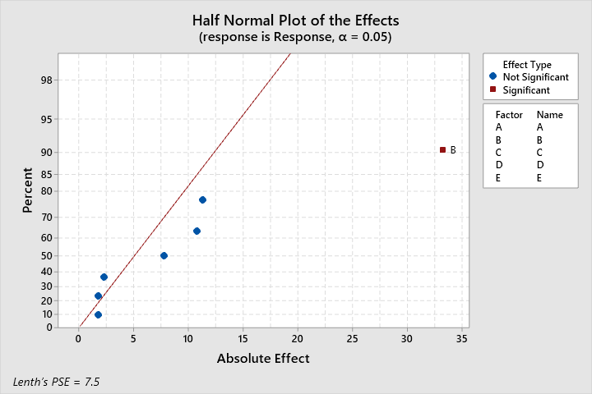

Per condition 8.411, the results of this analysis will be compared with the full model analysis of 6.30 data.

The full model analysis indicated that factor B was most significant with factors A, C, and AB meeting the significance threshold as well. Factors A and C were the second and third most significant factors per the coded coefficients table above while factor AB, being aliased as factor D in the fractional analysis, was fourth most significant, which is consistent with the fractional analysis.

Considering the sparsity of effects principle and the results of the fractional analysis, one might conclude that the main effects A, B, C, and D are most significant. The aliasing structure does introduce some uncertainty to whether the significance could be attributed to some alias interaction term, like AB = D.

***8.40*** *Consider the following experiment:*

|  |  |  |
| --- | --- | --- |
| **Run** | **Treatment Combination** | **y** |
| 1 | (1) | 8 |
| 2 | AD | 10 |
| 3 | BD | 12 |
| 4 | AB | 7 |
| 5 | CD | 13 |
| 6 | AC | 6 |
| 7 | BC | 5 |
| 8 | ABCD | 11 |

*Answer the following questions about this experiment:*

***8.40.a*** *How many factors did this experiment investigate?*

This is a 24-1IV design with **four factors** A, B, C, and D and design generator D = ABC.

The defining relation is D = ABC

A = A*I = BC = AD

B = AC = BD

C = AB = CD

D = ABCD

***8.40.b*** *What is the resolution of this design?*

Per table 8.14 p. 353, the resolution for this design is IV.

***8.40.c*** *Calculate the estimates of the effects.*

|  |  |  |  |  |  |  |
| --- | --- | --- | --- | --- | --- | --- |
| **Run** | **Treatment Combination** | **A** | **B** | **C** | **D = ABC** | **y** |
| 1 | (1) | - | - | - | - | 8 |
| 2 | AD | + | - | - | + | 10 |
| 3 | BD | - | + | - | + | 12 |
| 4 | AB | + | + | - | - | 7 |
| 5 | CD | - | - | + | + | 13 |
| 6 | AC | + | - | + | - | 6 |
| 7 | BC | - | + | + | - | 5 |
| 8 | ABCD | + | + | + | + | 11 |

Effect of factor X = Avg High Level Factor X Treatments – Avg Low Level Factor X Treatments

A = 0.25 * ( 10 + 7 + 6 + 11 – 8 – 12 – 13 – 5 ) = **-0.5**

B = 0.25 * ( 12 + 7 + 5 + 11 – 8 – 10 – 13 – 6 ) = **-2.375**

C = 0.25 * ( 13 + 6 + 5 + 11 – 8 – 10 – 12 – 7 ) = **-0.25**

D = 0.25 * ( 10 + 12 +13 + 11 – 8 – 7 – 6 – 5 ) = **-7.25**

***8.40.d***  *What is the complete defining relation?*

The product of the two sides of the defining relation D = ABC,

I = D*ABC = ABCD

***8.53*** *Heat treating is often used to carbonize metal parts, such as gears. The thickness of the carbonized layer is a critical output variable from this process, and it is usually measured by performing a carbon analysis on the gear pitch (top of the gear tooth). Six factors were studied on a 26-2IV design: A = furnace temperature, B = cycle time, C = carbon concentration, D = duration of the carbonizing cycle, E = carbon concentration of the diffuse cycle, and F = duration of the diffuse cycle. The experiment is shown in Table P8.16.*

**Table P8.16: The Heat Treating Experiment**

|  |  |  |  |  |  |  |  |  |
| --- | --- | --- | --- | --- | --- | --- | --- | --- |
| **Standard Order** | **Run Order** | **A** | **B** | **C** | **D** | **E** | **F** | **Pitch** |
| 1 | 5 | -1 | -1 | -1 | -1 | -1 | -1 | 74 |
| 2 | 7 | 1 | -1 | -1 | -1 | 1 | -1 | 190 |
| 3 | 8 | -1 | 1 | -1 | -1 | 1 | 1 | 133 |
| 4 | 2 | 1 | 1 | -1 | -1 | -1 | 1 | 127 |
| 5 | 10 | -1 | -1 | 1 | -1 | 1 | 1 | 115 |
| 6 | 12 | 1 | -1 | 1 | -1 | -1 | 1 | 101 |
| 7 | 16 | -1 | 1 | 1 | -1 | -1 | -1 | 54 |
| 8 | 1 | 1 | 1 | 1 | -1 | 1 | -1 | 144 |
| 9 | 6 | -1 | -1 | -1 | 1 | -1 | 1 | 121 |
| 10 | 9 | 1 | -1 | -1 | 1 | 1 | 1 | 188 |
| 11 | 14 | -1 | 1 | -1 | 1 | 1 | -1 | 135 |
| 12 | 13 | 1 | 1 | -1 | 1 | -1 | -1 | 170 |
| 13 | 11 | -1 | -1 | 1 | 1 | 1 | -1 | 126 |
| 14 | 3 | 1 | -1 | 1 | 1 | -1 | -1 | 175 |
| 15 | 15 | -1 | 1 | 1 | 1 | -1 | 1 | 126 |
| 16 | 4 | 1 | 1 | 1 | 1 | 1 | 1 | 193 |

***8.53.a*** *Estimate the factor effects and plot them on a normal probability plot. Select a tentative model.*

E = ABC and F = BCD are design generators for the 26-2IV design. The specified model with default alias structure is calculated using Minitab and the results of the model are displayed on page 6.

The factors A, D, E, and DE appear significant at the 0.05 significance level per the normal probability plot of effects on page 6. Factors CD and C appear marginally significance due to the deviations from the normal probability plot and the relatively large factor effects seen in Table 8.53.1. A reduced model containing these factors will be evaluated in the following sections.

**Alias Structure**

|  |
| --- |
| **Aliases** |
| I + ABCE + ADEF + BCDF |
| A + BCE + DEF + ABCDF |
| B + ACE + CDF + ABDEF |
| C + ABE + BDF + ACDEF |
| D + AEF + BCF + ABCDE |
| E + ABC + ADF + BCDEF |
| F + ADE + BCD + ABCEF |
| AB + CE + ACDF + BDEF |
| AC + BE + ABDF + CDEF |
| AD + EF + ABCF + BCDE |
| AE + BC + DF + ABCDEF |
| BD + CF + ABEF + ACDE |
| CD + BF + ABDE + ACEF |
| DE + AF + ABCD + BCEF |
| ABD + ACF + BEF + CDE |
| ABF + ACD + BDE + CEF |

**Table 8.53.1: Results of Minitab Analysis of Fractional Factorial Model**

|  |  |  |  |
| --- | --- | --- | --- |
| **Source** | **DF** | **Adj SS** | **Effect** |
| Model | 15 | 24359.0 |  |
| A | 1 | 10201.0 | 50.50 |
| B | 1 | 4.0 | -1.0000 |
| C | 1 | 676.0 | -13.000 |
| D | 1 | 5476.0 | 37.00 |
| E | 1 | 4761.0 | 34.50 |
| F | 1 | 81.0 | 4.500 |
| A*B | 1 | 64.0 | -4.000 |
| A*C | 1 | 25.0 | -2.500 |
| A*D | 1 | 64.0 | 4.000 |
| A*E | 1 | 4.0 | 1.0000 |
| B*D | 1 | 81.0 | 4.500 |
| C*D | 1 | 841.0 | 14.500 |
| D*E | 1 | 1936.0 | -22.00 |
| A*B*D | 1 | 1.0 | 0.5000 |
| A*B*F | 1 | 144.0 | 6.000 |

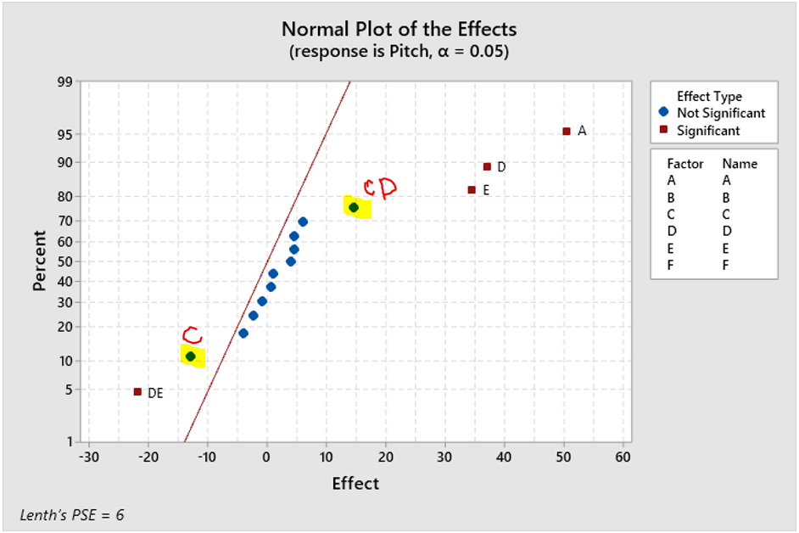

***8.53.b*** *Perform appropriate statistical tests on the model.*

* The model and statistical model parameters for the reduced model can be found on page 7.
* The model is significant at the standard 0.05 significance level.
* Variance inflation factors of 1 for the model parameters indicate that the model is free of multicollinearity.
* All included model terms and interactions are significant at the standard 0.05 significance level.
* The coefficient of variation for the model is 98.08, indicating that the model explains about 98% of the variation of the response for the 16 observations.

**Coded Coefficients**

|  |  |  |  |  |  |  |  |
| --- | --- | --- | --- | --- | --- | --- | --- |
| **Term** | **Effect** | **Coef** | **SE Coef** | **95% CI** | **T-Value** | **P-Value** | **VIF** |
| Constant |  | 135.75 | 1.80 | (131.67, 139.83) | 75.30 | 0.000 |  |
| A | 50.50 | 25.25 | 1.80 | (21.17, 29.33) | 14.01 | 0.000 | 1.00 |
| C | -13.00 | -6.50 | 1.80 | (-10.58, -2.42) | -3.61 | 0.006 | 1.00 |
| D | 37.00 | 18.50 | 1.80 | (14.42, 22.58) | 10.26 | 0.000 | 1.00 |
| E | 34.50 | 17.25 | 1.80 | (13.17, 21.33) | 9.57 | 0.000 | 1.00 |
| C*D | 14.50 | 7.25 | 1.80 | (3.17, 11.33) | 4.02 | 0.003 | 1.00 |
| D*E | -22.00 | -11.00 | 1.80 | (-15.08, -6.92) | -6.10 | 0.000 | 1.00 |

**Model Summary**

|  |  |  |  |  |  |  |
| --- | --- | --- | --- | --- | --- | --- |
| **S** | **R-sq** | **R-sq(adj)** | **PRESS** | **R-sq(pred)** | **AICc** | **BIC** |
| 7.21110 | 98.08% | 96.80% | 1479.11 | 93.93% | 135.99 | 121.60 |

**Analysis of Variance**

|  |  |  |  |  |  |  |  |
| --- | --- | --- | --- | --- | --- | --- | --- |
| **Source** | **DF** | **Seq SS** | **Contribution** | **Adj SS** | **Adj MS** | **F-Value** | **P-Value** |
| Model | 6 | 23891.0 | 98.08% | 23891.0 | 3981.8 | 76.57 | 0.000 |
| Linear | 4 | 21114.0 | 86.68% | 21114.0 | 5278.5 | 101.51 | 0.000 |
| A | 1 | 10201.0 | 41.88% | 10201.0 | 10201.0 | 196.17 | 0.000 |
| C | 1 | 676.0 | 2.78% | 676.0 | 676.0 | 13.00 | 0.006 |
| D | 1 | 5476.0 | 22.48% | 5476.0 | 5476.0 | 105.31 | 0.000 |
| E | 1 | 4761.0 | 19.55% | 4761.0 | 4761.0 | 91.56 | 0.000 |
| 2-Way Interactions | 2 | 2777.0 | 11.40% | 2777.0 | 1388.5 | 26.70 | 0.000 |
| C*D | 1 | 841.0 | 3.45% | 841.0 | 841.0 | 16.17 | 0.003 |
| D*E | 1 | 1936.0 | 7.95% | 1936.0 | 1936.0 | 37.23 | 0.000 |
| Error | 9 | 468.0 | 1.92% | 468.0 | 52.0 |  |  |
| Total | 15 | 24359.0 | 100.00% |  |  |  |  |

**Regression Equation in Uncoded Units**

|  |  |  |
| --- | --- | --- |
| Pitch | = | 135.75 + 25.25 A - 6.50 C + 18.50 D + 17.25 E + 7.25 C*D - 11.00 D*E |

**Fits and Diagnostics for Unusual Observations**

|  |  |  |  |  |  |  |  |  |  |  |  |
| --- | --- | --- | --- | --- | --- | --- | --- | --- | --- | --- | --- |
| **Obs** | **Pitch** | **Fit** | | | **SE Fit** | **95% CI** | **Resid** | **Std Resid** | **Del Resid** | **HI** | **Cook’s D** |
| 8 | 144.00 | 157.00 | | | 4.77 | (146.21, 167.79) | -13.00 | -2.40 | -3.79 | 0.4375 | 0.64 |
| **Obs** | **DFITS** | |  |
| 8 | -3.34022 | | R |

*R  Large residual*

***8.53.c*** *Analyze the residuals and comment on model adequacy.*

The residual plots can be found on page 8. The following is an analysis of the residual plots.

* The residuals appear normally distributed about the predicted values, having a p-value of 0.236 for the Anderson-Darling normality test.
* The independence assumption can be verified upon inspection of the run-order plot. The run order plot appears random and does not indicate a pattern with respect to run order.
* The residuals versus residual plots do not indicate significant problems with homogeneity of variance.

Considering the conclusions above, the model is adequate.

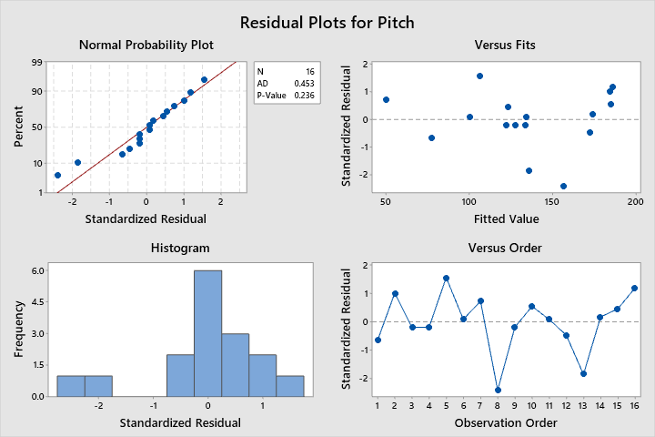

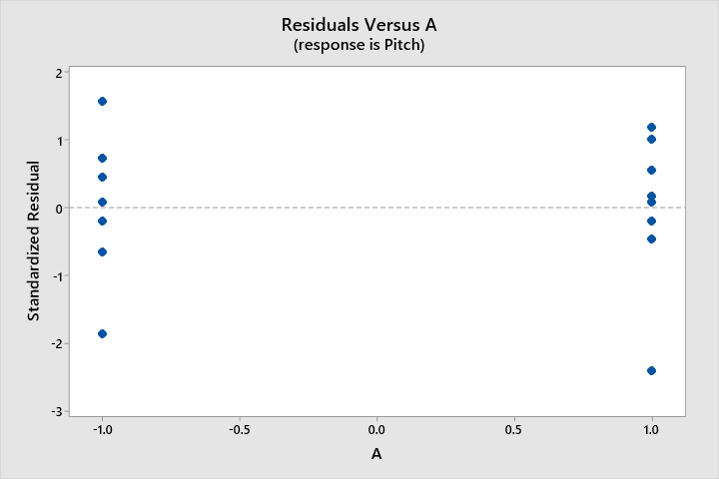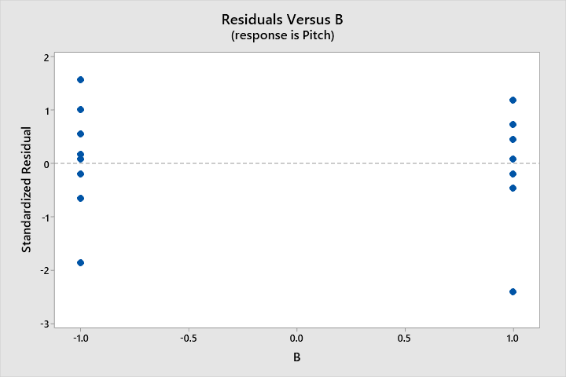

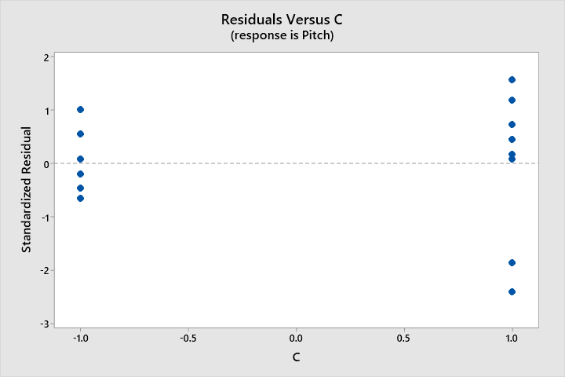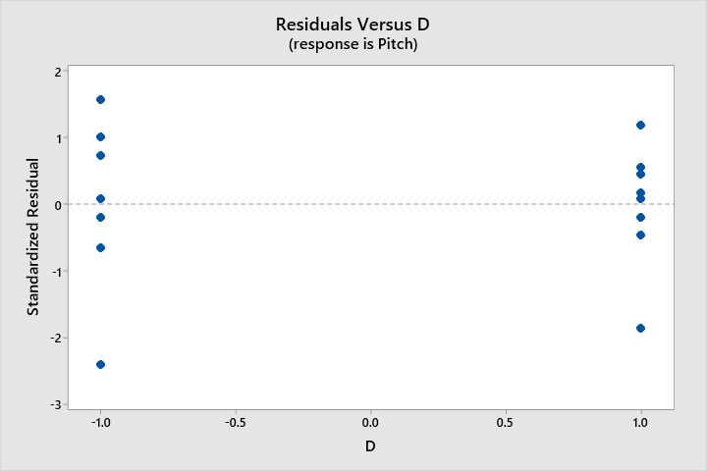

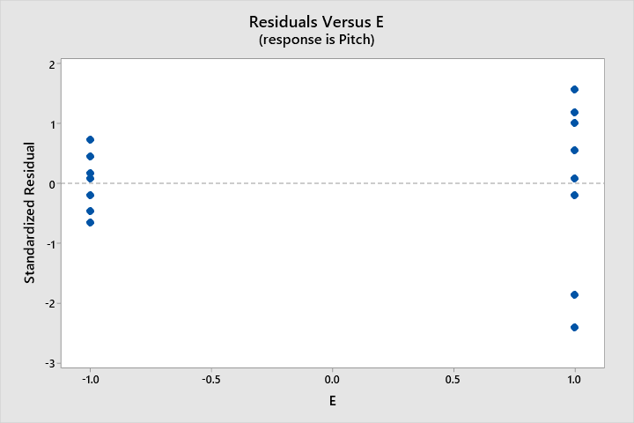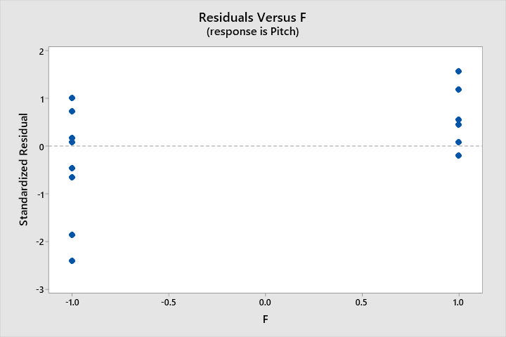

***8.53.d*** *Interpret the results of this experiment. Assume that a layer thickness of between 140 and 160 is desirable.*

The main effect and interaction plots below indicate a factor combination of (A, C, D, E) = (+1, -1, +1, +1) could be useful for attaining the desired pitch between 140 and 160.

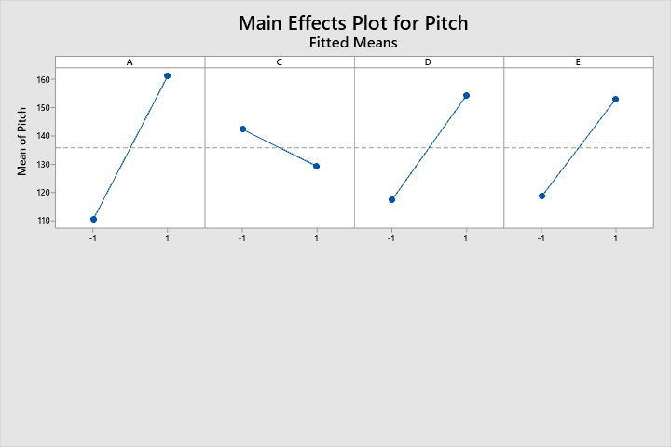

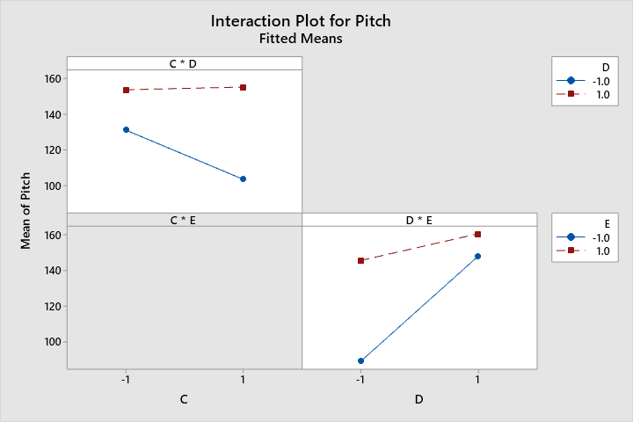

Per condition 8.53+, the preceding analysis will also be performed in SAS. Discussions will not be repeated. The SAS code used to perform this analysis is as follows:

/*

STAT 8120 - Module 8 HW

*/

libname hw8 "C:\Users\conno\OneDrive\Desktop\STAT 8120 - Applied Experimental Design\Module 8";

**run**;

**proc** **import** datafile = "C:\Users\conno\OneDrive\Desktop\STAT 8120 - Applied Experimental Design\Module 8\S8120Ch8Data122317.xlsx"

out = hw8.q3

DBMS = xlsx

Replace;

sheet = "P8.53";

**run**;

ods rtf;

ods graphics on;

*full model with default aliasing;

**proc** **glm** data = hw8.q3;

model pitch = A B C D E F A*B A*C A*D A*E B*D C*D D*E A*B*D A*B*F / solution aliasing;

**run**;

*chosen reduced model;

**proc** **glm** data = hw8.q3;

class A C D E;

model pitch = A C D E C*D D*E / solution aliasing;

output out = stdres student = stdresidual;

**run**;

LSMeans A C D E / Pdiff = All;

**run**;

Means A C D E / LSD;

**run**;

**proc** **univariate** data = stdres normal;

var stdresidual;

qqplot stdresidual / normal(mu=est sigma=est);

histogram/normal;

**run**;

**proc** **sgplot** data = stdres;

scatter x=A y=stdresidual;

**run**;

**proc** **sgplot** data = stdres;

scatter x=C y=stdresidual;

**run**;

**proc** **sgplot** data = stdres;

scatter x=D y=stdresidual;

**run**;

**proc** **sgplot** data = stdres;

scatter x=E y=stdresidual;

**run**;

ods graphics off;

ods rtf close;

Relevant SAS Output:

| **Source** | **DF** | **Type I SS** | **Mean Square** | **F Value** | **Pr > F** |
| --- | --- | --- | --- | --- | --- |
| **A** | 1 | 10201.00000 | 10201.00000 | . | . |
| **B** | 1 | 4.00000 | 4.00000 | . | . |
| **C** | 1 | 676.00000 | 676.00000 | . | . |
| **D** | 1 | 5476.00000 | 5476.00000 | . | . |
| **E** | 1 | 4761.00000 | 4761.00000 | . | . |
| **F** | 1 | 81.00000 | 81.00000 | . | . |
| **A*B** | 1 | 64.00000 | 64.00000 | . | . |
| **A*C** | 1 | 25.00000 | 25.00000 | . | . |
| **A*D** | 1 | 64.00000 | 64.00000 | . | . |
| **A*E** | 1 | 4.00000 | 4.00000 | . | . |
| **B*D** | 1 | 81.00000 | 81.00000 | . | . |
| **C*D** | 1 | 841.00000 | 841.00000 | . | . |
| **D*E** | 1 | 1936.00000 | 1936.00000 | . | . |
| **A*B*D** | 1 | 1.00000 | 1.00000 | . | . |
| **A*B*F** | 1 | 144.00000 | 144.00000 | . | . |

| **Parameter** | **Estimate** | **Standard Error** | **t Value** | **Pr > |t|** | **Expected Value** |
| --- | --- | --- | --- | --- | --- |
| **Intercept** | 135.7500000 | . | . | . | Intercept |
| **A** | 25.2500000 | . | . | . | A |
| **B** | -0.5000000 | . | . | . | B |
| **C** | -6.5000000 | . | . | . | C |
| **D** | 18.5000000 | . | . | . | D |
| **E** | 17.2500000 | . | . | . | E |
| **F** | 2.2500000 | . | . | . | F |
| **A*B** | -2.0000000 | . | . | . | A*B |
| **A*C** | -1.2500000 | . | . | . | A*C |
| **A*D** | 2.0000000 | . | . | . | A*D |
| **A*E** | 0.5000000 | . | . | . | A*E |
| **B*D** | 2.2500000 | . | . | . | B*D |
| **C*D** | 7.2500000 | . | . | . | C*D |
| **D*E** | -11.0000000 | . | . | . | D*E |
| **A*B*D** | 0.2500000 | . | . | . | A*B*D |
| **A*B*F** | 3.0000000 | . | . | . | A*B*F |

Reduced Model output:

| **Source** | **DF** | **Sum of Squares** | **Mean Square** | **F Value** | **Pr > F** |
| --- | --- | --- | --- | --- | --- |
| **Model** | 6 | 23891.00000 | 3981.83333 | 76.57 | <.0001 |
| **Error** | 9 | 468.00000 | 52.00000 |  |  |
| **Corrected Total** | 15 | 24359.00000 |  |  |  |

| **R-Square** | **Coeff Var** | **Root MSE** | **Pitch Mean** |
| --- | --- | --- | --- |
| 0.980787 | 5.312046 | 7.211103 | 135.7500 |

| **Source** | **DF** | **Type I SS** | **Mean Square** | **F Value** | **Pr > F** |
| --- | --- | --- | --- | --- | --- |
| **A** | 1 | 10201.00000 | 10201.00000 | 196.17 | <.0001 |
| **C** | 1 | 676.00000 | 676.00000 | 13.00 | 0.0057 |
| **D** | 1 | 5476.00000 | 5476.00000 | 105.31 | <.0001 |
| **E** | 1 | 4761.00000 | 4761.00000 | 91.56 | <.0001 |
| **C*D** | 1 | 841.00000 | 841.00000 | 16.17 | 0.0030 |
| **D*E** | 1 | 1936.00000 | 1936.00000 | 37.23 | 0.0002 |

| **Source** | **DF** | **Type III SS** | **Mean Square** | **F Value** | **Pr > F** |
| --- | --- | --- | --- | --- | --- |
| **A** | 1 | 10201.00000 | 10201.00000 | 196.17 | <.0001 |
| **C** | 1 | 676.00000 | 676.00000 | 13.00 | 0.0057 |
| **D** | 1 | 5476.00000 | 5476.00000 | 105.31 | <.0001 |
| **E** | 1 | 4761.00000 | 4761.00000 | 91.56 | <.0001 |
| **C*D** | 1 | 841.00000 | 841.00000 | 16.17 | 0.0030 |
| **D*E** | 1 | 1936.00000 | 1936.00000 | 37.23 | 0.0002 |

| **Parameter** | **Estimate** | **Standard Error** | **t Value** | **Pr > |t|** | **Expected Value** |
| --- | --- | --- | --- | --- | --- |
| **Intercept** | 135.7500000 | 1.80277564 | 75.30 | <.0001 | Intercept |
| **A** | 25.2500000 | 1.80277564 | 14.01 | <.0001 | A |
| **C** | -6.5000000 | 1.80277564 | -3.61 | 0.0057 | C |
| **D** | 18.5000000 | 1.80277564 | 10.26 | <.0001 | D |
| **E** | 17.2500000 | 1.80277564 | 9.57 | <.0001 | E |
| **C*D** | 7.2500000 | 1.80277564 | 4.02 | 0.0030 | C*D |
| **D*E** | -11.0000000 | 1.80277564 | -6.10 | 0.0002 | D*E |

| **Tests for Normality** | | | | |
| --- | --- | --- | --- | --- |
| **Test** | **Statistic** | | **p Value** | |
| **Shapiro-Wilk** | **W** | 0.931558 | **Pr < W** | 0.2580 |
| **Kolmogorov-Smirnov** | **D** | 0.178958 | **Pr > D** | >0.1500 |
| **Cramer-von Mises** | **W-Sq** | 0.069953 | **Pr > W-Sq** | >0.2500 |
| **Anderson-Darling** | **A-Sq** | 0.453107 | **Pr > A-Sq** | 0.2408 |











